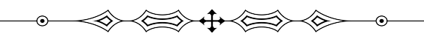
BIODATA

Affix Passport Size Photo Here

Name: ✆ Mobile:
Gender: Email id:
DOB:
Age:

Other Details

Caste :
Religion :
Father’s Name :
Mother’s Name :
Height :
Weight :
Education :
Job :
Company Name :
Salary :
Siblings :
Address :

