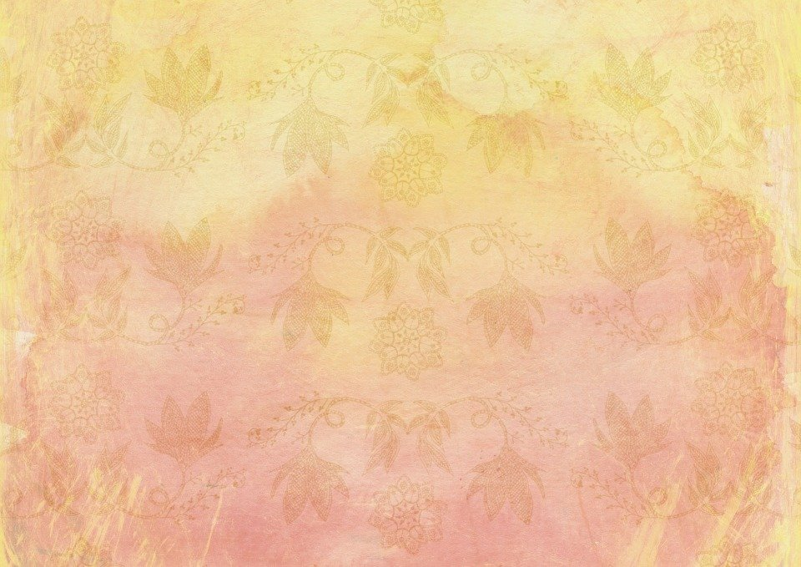
BIODATA
Mobile:
Email ID:

Full Name :
Affix Photograph
Date of Birth :
Birth Time :
Place of Birth :
Mangal :
Devak/Gotra :
Astrology Gan :
Astrology Naadi :
Complexion :
Height :
Weight :
Blood Group :
Education :
Occupation :

Family Details

Father/Mother :
Brothers :
Sisters :
Father’s Name :
Father’s Occupation :
Mother’s Name :
Family Properties :
Residential Address :

