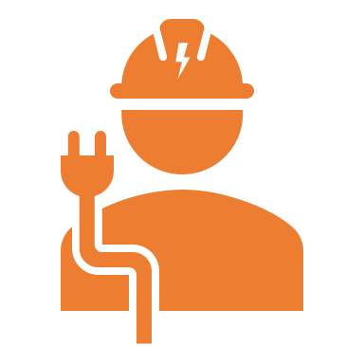

**Worked as a Jr Electrical Engineer at PVR Constructions from 01 Feb 2019 to 31 Dec 2020.**

**Date of birth:**  21 Nov 1998

**Gender:** Male

**Marital Status:** Unmarried

**Father’ Name**: Vamana Murthy

**Languages Known:** English,

Hindi and Telugu

**Religion:** Hindu

**Hobbies:** Reading books & Playing cricket

* B. Tech Electrical Engineering in 2021, JNTUH College of Hyderabad, GPA 7.5
* Intermediate (MPC) 2017, Nalanda Jr College, GPA 8.5.
* 10th class, Hyderabad Public School. 8.7 GPA.

**EDUCATION**

**RESPONSIBILITIES**

* Designing of transmission and distribution systems.
* Preparation of key SLD, protection control SLDs, cable designs and bulk MTOs
* Overseeing maintenance, inspection and system upgrade programs
* Calculation of earthing lighting protection
* Coordinating with clients, contractors and suppliers
* Submit project report for all projects from electrical side
* Carry out test systems, monitoring installation of services and managing their maintenance.
* Supervision of erection, testing and recommissioning etc.
* Planning, scheduling and monitoring the substation erection, Testing and commissioning of HT/LT capacitor bank
* HT extension and renovation work
* Inspection of material procured by E&I sub-contractors
* Supervising installation of power panel and control panel boards.
* Reviewing drawings of different electrical systems and installations
* Checking and issuing the material to execute the approved drawings.

**RESPONSIBILITIES**

**CONTACT DETAILS**

Photo

**KISHORE GUDURU**

**Present Working as an Electrical Engineer at Ansal Construction Company from 02 Jan 2021**

**PERSONAL INFORMATION**

* AutoCAD
* SCADA
* MS Office

**COMPUTER SKILLS**

**Email ID:**

muralichpxx@gmail.com

**Mobile:**

9492XXXX48

**Address:**

H No: 5-24, Adarsh Nagar, Hyderabad,

Telangana 500063.

**PROFILE SUMMARY**

A self-driven and result oriented electrical engineer with 2+ years of experience in designing, installation and testing of electrical systems looking for a better opportunity to get more exposure in the field of electrical engineering.

**PROFESSIONAL EXPERIENCE**