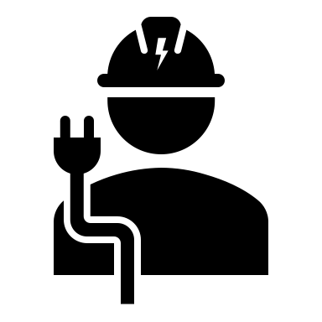

* AutoCAD
* SCADA
* MS Office
* Knowledge of electrical system design and construction.
* Good knowledge in power system analysis.
* Ability to read electrical documentation.
* Knowledge in preventive and corrective maintenance
* Knowledge in circuit designing and PCB designing.
* Knowledge about power consuming guidelines
* Knowledge in HT and LT related applications
* Effective Communication skills.
* Can prepare main plant Single line diagram (key SLD)
* Inspection and documentation handling.

**Computer Skills**

**Date of birth:**  04 April 99

**Gender:** Male

**Marital Status:** Unmarried

**Father’ Name**: Girish Kumar

**Languages Known:** English,

Hindi and Tamil

**Religion:** Hindu

**Hobbies:** Reading books & Listening to music.

**Contact Details**

**Personal Information**

**Skills**

**Profile Summary**

**Education**

**ANUDEEP SAI**

**KONURU**

Photo

**Email ID:** anudeepxxx@gmail.com

**Mobile:**

9315XXXX75

**Address:**

H No: 123-4, Azad Nagar, Chennai,

Tamil Nadu 600014.

* Completed B. Tech Electrical Engineering in 2021 from SRR Engineering College, Chennai with GPA 7.5
* Intermediate (MPC) 2017 from Narayana Jr College, Chennai with GPA 8.5.
* 10th class from Chennai Public School, Chennai in 2015 with 8.7 GPA.

A B.Tech/BE Electrical engineering student looking to working in a growth-oriented organization which offers me challenging opportunities to enhance my profession and technical knowledge.