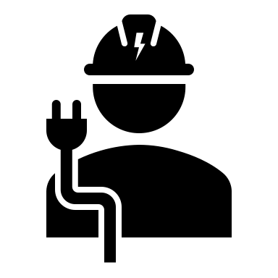

* Basics of C
* AUTOCAD
* Mastercam
* Solid Edge 2D Drafting
* Pro/E Wildfire 2.0
* Ansys 10.0
* Knowledge of mechanical activities in the manufacturing units.
* Ability to resolve problems/deficiencies.
* Fundamental knowledge in design, procurement, documentation and manufacturing
* Knowledge of codes and standards like ASME, ANSI, DIN, EN, ISO, API and MSS
* Good interpersonal skills and ability to work with teams
* Ability to inspect material and equipment and supervise installation activities.

**Computer Skills**

**Skills**

* B. Tech Mechanical Engineering in 2022 from Gayatri Engineering College, Visakhapatnam with GPA 8
* Intermediate MPC in 2018 from Narayana Jr College, Visakhapatnam with GPA 8.5
* 10th Standard 2016 from SRR Vidya Mandir, Visakhapatnam with GPA 8.9

B. Tech mechanical engineering graduate looking for an opportunity in a growth-oriented organization which offers me challenging opportunities to enhance my professional and technical knowledge.

Photo

**Date of birth:**  02 July 1999

**Gender:** Male

**Marital Status:** Unmarried

**Father’ Name**: Gangadahar S

**Languages Known:** English,

Hindi and Tamil

**Religion:** Hindu

**Hobbies:** Reading books & Playing Chess.

**Contact Details**

**Personal Information**

**Career Objective**

**Education**

**Chaitanya**

**Siriki**

**Email ID:** anudeepxxx@gmail.com

**Mobile:**

9315XXXX75

**Address:**

H No: 123-4, Azad Nagar, Chennai,

Tamil Nadu 600014.