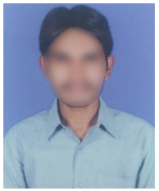
Konuru Srinivas
Address: D No: 123-1, Pandeypur,
Paharia, Varanasi,
Uttar Pradesh 221007.
Email: srinuknrxx@gmail.com
Mobile: 9395XXXX20.

Career Objective
- To start a career in a challenging and growth oriented organization to effectively use skills and excel as a professional to achieve greater heights and recognition in career.

Educational Qualification

Qualification | Institution | Year of Passing | GPA
B. Tech (CSE) | Amity University | 2022 | 8
Intermediate | Montfort Inter College | 2018 | 8.5
10th Class | City Montessori School | 2016 | 8.4

Technical Skills
- Programming languages: Core Java,
- Web technologies: HTML, CSS
- Web Servers: Apache tomcat.
- Database: Oracle, MYSQL
- Operating Systems: Windows 10, Linux

Achievements
- Won awards in painting competitions
- Won several awards in technical paper presentation.
- NCC head during graduation.

Declaration
I do hereby declare that all the above furnished information is true to the best of my knowledge and belief.

Place:
Date: Srinivas K.

