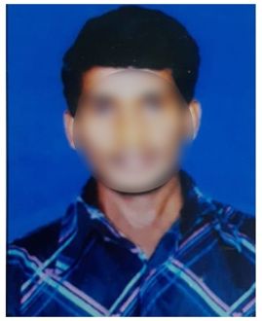
RESUME

ADITYA KALLAPALLI
Email Id: adityaklpxx@gmail.com
Mobile: +91 9845XXXX70
Address: 5-251, Sector 2,
Mayapuri, New Delhi 110064.

Objective:
Seeking innovative and challenging career in a growing organization which gives me an opportunity to utilize my skills & knowledge and provides me an opportunity for career growth.

Academic Profile:
- B.Com computer from Sri Venkateshwara College in 2022
- Intermediate C.E.C from Govt Junior College in 2019
- 10th from CBSE board in in 2017

Technical Expertise:
- Tally ERP
- MS Excel, Word and PowerPoint

Skills:
- Good communication skills
- Quick learner
- Ability to work independently
Personal Information
Father’s name : Mohan Rao K
Date of birth : 07 September 2001
Gender : Male
Marital Status : Unmarried
Nationality : Indian
Languages Known : English and Hindi
Hobbies : Reading Books

Declaration: all the above information is correct up to my knowledge and I bear the responsibility of the correctness.

Place:
Date: Aditya K

