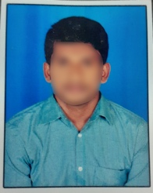
RESUME
AVINASH PADALA
Email id: avinashpdlxx@gmail.com
Mobile No: 8500XXXX75.
Address: H No: 8-145, Ganesh Nagar,
Madhruawada, Visakhapatnam 5300045.

CAREER OBJECTIVE
- Obtain a responsible position in an organization with the best capabilities, skills and knowledge.

ACADEMIC QUALIFICATION:
- 12th from Narayana Jr College.
- 10th from St Theresa High school.

PROFESSIONAL SKILLS:
- Basic knowledge of computer.
- Typing

WORK EXPERIENCE:
- Fresher

PERSONAL DETAILS:
Father’s Name : Ram Mohan P
Date of birth : 05 April 2002
Gender : Male
Nationality : Indian
Marital Status : Unmarried
Languages Known : English & Telugu
Hobbies : Playing Cricket

Place:
Date: Avinash P

