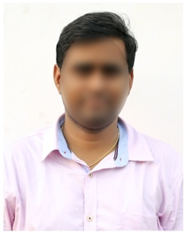
NAVEEN CHAPPA
Email Id: naveenchxx@gmail.com
Mobile: 7352XXXX25.
Address: H No 12-2, Narayanaguda,
Hyderabad, Telangana 500027.

CAREER OBJECTIVE
- To obtain a challenging career in the IT industry and put all my efforts into the growth of the organization and have a great working environment.
SUMMARY
- An enthusiastic, punctual & carer minded individual with excellent communication and interpersonal skills.
TECHNICAL PROFICIENCY
- Languages: C, C++, JAVA,
- Databases: SQL, My SQL
- Web Technologies: Servlets, JSP
- Operating Systems: Windows 2000/Xp
EDUCATIONAL QUALIFICATION
- B.Tech Computer Science (CSE) from Andhra University.
- Intermediate from Sri Chaitanya Jr College.
PROJECT WORK
Title: XXXX
Duration: 2 months
Project Description:

EXPERIENCE
Fresher
PERSONAL PROFILE
Father’s Name : Raghuram Ch
Date of birth : 05 July 2000
Gender : Male
Nationality : Indian
Languages Known : English, Hindi & Telugu
Religion : Hindu
Hobbies : Reading Books

DECLARATION
I hereby declare that all the above mentioned information is true to the best of my knowledge and belief.

Place:
Date: Naveen Chappa

