BIO-DATA
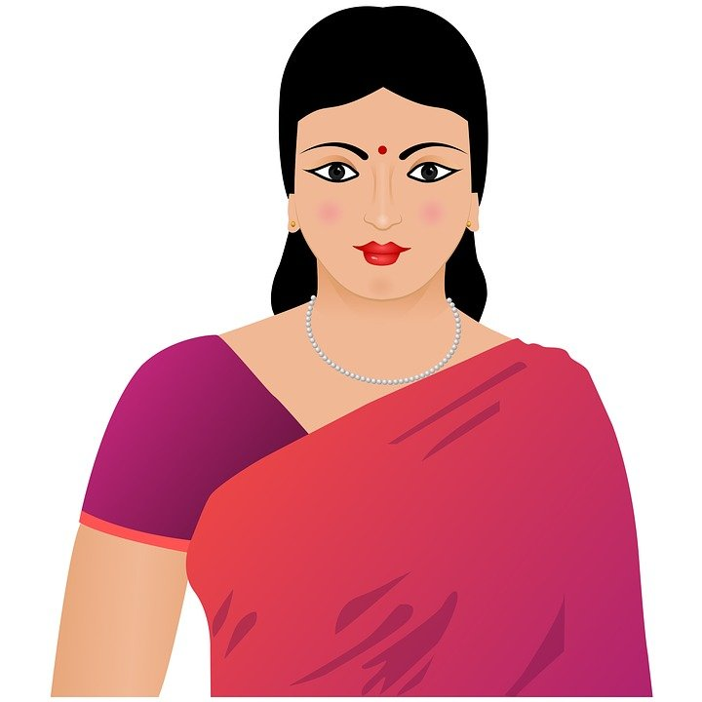
Name : Archana Kallapalli
Date of Birth : 05 June 1990
Birth Time : 12:05 AM
Birth Place : Hyderabad
Complexion : Fair
Weight : 52 Kgs
Height : 5 Feet 2 Inches
Rashi : Libra
Religion : Hindu
Gotra : Nagula
Gan : Kashyapa
Education : B. Com Computers
Occupation : Accountant at Varun Motors Pvt Ltd

FAMILY BACKGROUND
Father : Ravindra
Father’s Occupation : Self Employed
Mother : Lakshmi
Mother’s Occupation : Home Maker
Brother : -
Sister : Younger Sister, Studying B.Sc.

CONTACT DETAILS
Address : H No: 2-124, Balanagar, Musapet,
Hyderabad, Telangana 500018.
Mobile No : 9456XXXX20
Email ID : archanklpxx@gmail.comv

***

