ANUDEEP PADALA
Mobile No: 9542XXXX50
Email id: anudeeppdlxx@gmail.com

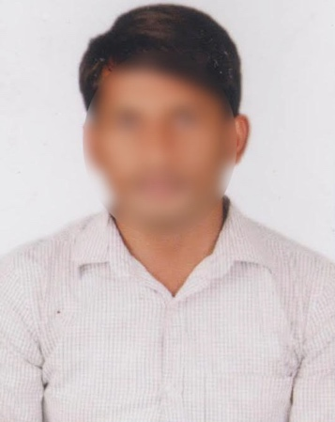
Date of Birth : 21 July 2000
Gender : Male
Father’s Name : Ravi Kumar
Religion : Hindu
Nationality : Indian
Marital Status : Unmarried
Languages Known : English & Telugu
Education
Education | University/College | Year of Pass | Marks
B. Com Computers | Aditya Degree College | 2022 | 7 GPA
Intermediate C.E.C | Krishna College | 2020 | 7.2 GPA
10th Class | MCH School | 2018 | 7.5 GPA

Experience : Fresher

Address : 8-124, Ganesh Nagar, Chandram Palem,
Madhurawada, Visakhapatnam, Andhra Pradesh 530048.

Declaration: I hereby declare that all the above information is true to the best of my knowledge and belief.

Place: Visakhapatnam
Date: 04 Sep 2022 Signature

