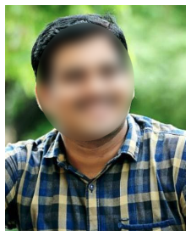

**Project Title:** Rural Road Development.

**Duration:** 2 months

**Description:** To study the quality control mechanism to ensure the construction of quality roads in rural areas for safe and quick transport.

**PROJECTS**

To work in a firm with a professional work driven environment where I can utilize my skills, knowledge to achieve the organization goals and to advance my career as well.

DOB : 16 Jun 2000

Gender : Male

Father’s Name : Krishna Murthy

Marital Status : Unmarried

Hobbies : Reading books &  
 Playing Chess  
Languages Known : English, Hindi & Tamil

**PERSONAL INFORMATION**

* Excellent communication skills
* Creative thinking and innovation
* Problem solving skills
* Auto CAD
* Revit Architecture
* MS Office (Excel, Word & PowerPoint)

**OTHER SKILLS**

**TECHNICAL SKILLS**

* B. Tech in Civil Engineering from Jawahar Engineering College in 2021 with GPA 8
* Intermediate MPC from St Johns Educational Trust in 2017 with GPA 8.1
* 10th Class from Vidyamandir Sr Secondary School in 2015 with GPA 7.5

**EDUCATION**

**Address**: Flat No: 301, 3rd Floor, Vasanth Apartments, Nungambakkam, Chennai, Tamil Nadu 600034.

**SRIKANTH NAYYAR**

**Email id: srikanthnyrxx@gmail.com  
Mobile No. 9551XXXX20**

**ABOUT ME**