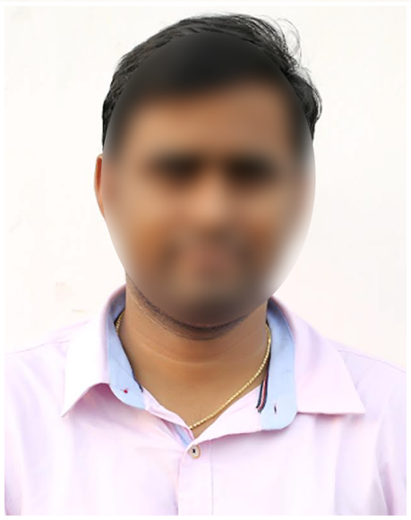

* Excellent communication skills (verbal & written)
* Strong analytical skills and attention to details.
* Good leadership skills.

**OTHER SKILLS**

**SKILLS**

**EDUCATION**

**DOB** : 01 Mar 2000

**Gender:** Male

**Father’s Name:** Prasanth Bhushan

**Marital Status:** Unmarried

**Hobbies:** Listening to Music & Playing Cricket  
**Languages Known:** English, Hindi & Gujarati

**PERSONAL INFORMATION**

**CAREER OBJECTIVE**

* HTML, CSS and JavaScript
* Python
* Django
* Flask
* MCA from Gujarat University in in 2022 with GPA 7.5
* B. Sc Computers from St. Xavier’s College, in 2020 with GPA 8
* Intermediate from Triveni Intermediate College in 2017 with GPA 7.9
* 10th Class from Little Flower High School in 2014 with GPA 8.1

**ADDRESS**

D No: 58-152, Athwa, Surat, Gujarat 395001

**MOBILE NO.**

8502XXXX55

ravikshxx@gmail.com

**EMAIL ID**

**RAVI KISHORE DESAI**

Looking for an entry level opportunity as a ………………[Designation] in ………………… industry, where I can apply my skills and knowledge for the professional growth of the company.