Girish Nayyar
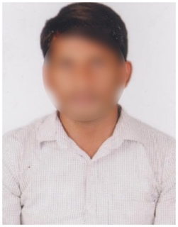
Email: girishnyrxx@gmail.com
Mobile: 9355XXXX70
H No: Flat no 301, 3rd Floor,
Vasanth Apartments, Nungambakkam,
Chennai, Tamil Nadu 600034.

Professional Summary

A marketing professional with over 7 years of experience in leading marketing campaigns, executing strategy and promoting business.

Work Experience

Working as a Sales Manager at ABC Technologies Pvt Ltd since 01 Mar 2021.
Key Responsibilities:
- Analyze business potential and execute strategies to drive sales.
- Ensure maximum brand visibility and capture optimum market share.
- Monitor competitor activities and plan effective counter measures.
- Analyze market trends and sales performance
- Maintain communication with advertising and PR agencies for management of advertisement campaigns.
- Handle all administrative work in sales aspects such as customer relationship management, enquiries, warranties, and payments etc.
- Work closely with team leaders & sales executives to successfully implement road map.

Worked as a Asst Marketing Manager at XYZ Tech Pvt Ltd from 05 Jan 2016 to 28 Feb 2020.
Key Responsibilities:
- Work closely with stake holders and business leaders to understand business goals.
- Support the manager by monitoring and executing daily B2C operational tasks.
- Increasing brand awareness and market share.
- Conducting competitor/market analysis by observing market trends and competitor moves.
- Negotiation and following up with the clients.
- Providing post sale technical support

Educational Qualifications
- M.B.A from Presidency College in 2014 with CGPA 7.8
- B.Sc. Computers from Guru Nanak College in 2012 with CGPA 7.5
- Intermediate (MPC) from St Johns Educational Trust in 2009 with CGPA 8
- 10th Class from Vidya Mandir Secondary School in 2007 with CGPA 8.1

Key Skills
- Strong communication and interpersonal skills
- Adaptability and resilience
- Time management
- Critical thinking and problem solving
- Good team player
- Knowledge of computers (MS Word, Excel & PowerPoint)

Personal Details

Date of Birth : 15 Sep 1996
Gender : Male
Marital Status : Married
Father’s Name : Krishna Murthy
Languages Known : English & Tamil
Hobbies : Reading books & Playing Cricket
Religion : Hindu

Declaration
All the above information is correct up to my knowledge and I bear the responsibility of the correctness of the above information.

Place:
Date: Signature.

