BIO DATA
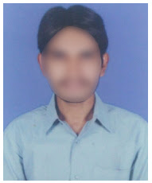
Name : Sandeep Desai
Father’s Name : Aravind Babu
Mobile : 9452XXXX50
Email ID : sandydxxx@gmail.com
Gender : Male
Date of Birth : 02 Feb 2001
Marital Status : Married
Religion : Hindu
Nationality : India
Languages Known : English, Hindi & Gujarati.
Education:
Exam Name | Year of Pass | Institution Name | Marks
Elementary | 2017 | Little Flower High School | 8.5
College | 2019 | Triveni Intermediate College | 8.6
Degree | 2023 | St. Xavier’s College | 7.5
Tally ERP Course | 2023 | Online Course (Udemy)

Computer Knowledge : MS Office, Tally ERP 9
Work Experience : Fresher
Address : 8-121. Atha, Surat, Gujarat - 395001.

Declaration
I do hereby declare that the above information is true to the best of my knowledge

Place: Surat
Date: 15 Apr 2023 Signature

