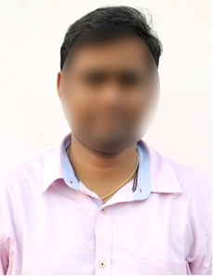
PRASANTH ADVANI
Email ID: prasanthadvxx@gmail.com
Mobile: 7556XXXX725,
Address: H No 2-145, Sector 2,
Mayapuri, New Delhi 110064.

PROFILE SUMMARY
A mechanical engineer (1+ Year experience) who has been able to handle multiple projects and possesses exceptional technical skills, including computer aid designing, problem-solving, and commercial awareness, obtaining a challenging and rewarding position.
ACADEMIC QUALIFICATION

- B. Tech Mechanical Engineering from Pusa Institute of Technology in 2022with 7.8 GPA
- Intermediate MPC from Sri Chaitanya Junior Science College in 2018 with GPA 7.5
- 10th Standard Bal Bharathi Public School in 2016 with GPA 8.1

WORK EXPERIENCE

Currently Working as a Mechanical engineer at XYZ Engineers Pvt Ltd since 01 Aug 2023.
Major Job Responsibilities:
- Create mechanical designs using Auto CAD.
- Ensure the devices are safe and efficient.
- Test mechanical devices for performance, safety, and durability.
- Identify and troubleshoot mechanical problems to develop solutions.
- Communication with the clients and other engineers to explain about the designs.
- Prepare product reports and documentation.
- Collaborate with other team members to manage projects.

TECHNICAL SKILLS
- AUTOCAD, SolidWorks
- MATLAB
- MS Office (Excel, Word & PowerPoint)

KEY SKILLS
- Ability to draw mechanical designs, 3D modellings, verification of designs and testings.
- Capability to analyze problems and deficiencies and developing to solutions to resolve them.
- Ability to design plans using CAD technology.
- Ability to estimate budget and time scope for each project
- Ability to write technical documentation for machine operators
- Strong problem solving and critical thinking skills
- Knowledge of quality assurance practices, industry regulatory codes and standards

PERSONAL DETAILS
Date of birth : 15 Nov 2000
Gender : Male
Marital Status : Unmarried
Father’s Name : Aravindh Kumar
Languages Known : English & Hindi
Hobbies : Listening to music, Reading books
Religion : Hindu

DECLARATION

I hereby declare that the above-mentioned information is correct to best of my knowledge, and I bear the responsibility for the same.

Place:
Date: Signature.

