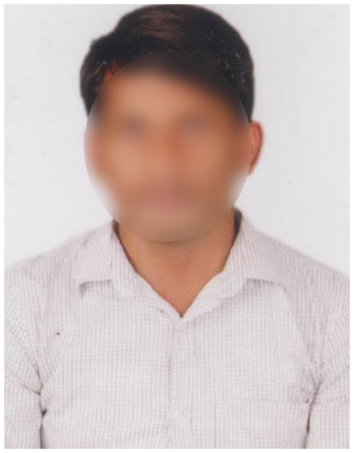

**Profile Summary**

At present working as a Jr Python Developer at XYZ Tech Solutions from 01 Aug 2022.

**Major Job Responsibilities:**

* Write a clean and well documented Python code as per the coding standards.
* Debug and troubleshoot the code.
* Collaborate with other Python developers to build and maintain Python projects
* Test and deploy applications.
* Write technical documentation, user guides and tutorials.
* Provide support to the users when they face any problems.

**Work Experience**

* Python
* Django Flask frameworks
* Git and GitHub

Software professional with 1 year experience in developing, designing, deploying, and debugging computer applications in Python.  I want to associate with a progressive organization that allows me to apply my knowledge and advance my career.

DOB: 15 Sep 2001

Gender: Male

Father’s Name: Raghuram

Marital Status: Unmarried

Hobbies: Reading books &  
Listening to music  
Languages Known: English, Hindi & Telugu

**Personal Info**

**Skills**

**Education**

**Vinay Kumar Chappa**

* B. Tech Computer Science from Brindavan Group of Institutions in 2022 with GPA 8.4
* Intermediate MPC from BBMP Jr College in 2018 with GPA 8.4
* 10th Class from Presidency School in 2016 with GPA 8.6

**Address**: 4-145, Ashok Nagar, Bangalore,

Karnataka 56005.

**Email id:** vinaykmrxx@gmail.com **Mobile No:** 9545XXX45