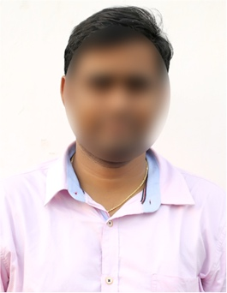
KISHORE PADALA

Mobile: 94123XXX75.
Email ID: kishorepdl@gmail.com
Address: 2-165, Madhurawada,
Visakhapatnam, Andhra Pradesh 530045.

CAREER OBJECTIVE
Aspiring sales Executive with a high ability in dealing with customers and providing service. Looking for employment in a highly esteemed organization that provides challenging opportunities and an excellent work environment that utilizes my skills and strengths.

EDUCATION
- B. Com Computers from Pydah Degree College in 2023 with 8 GPA.
- Intermediate from Sri Chaitanya Junior College in 2020 with 82%.
- SSC from Srividya Niketan in 2018 with 85%.

KEY SKILLS
- Identifying opportunities.
- Interpersonal skills
- Networking skills
- Negotiation skills
- Client-centricity
- Closing skills

PERSONAL DETAILS

Gender : Male
Date of birth : 05/07/2003
Father’s Name : Raghuram
Nationality : Indian
Marital Status : Unmarried
Hobbies : Reading books & Playing Cri
Languages known : English, Hindi & Telugu

Declaration: I here by certify that all the above information is true to the best of my knowledge.

Place:
Date: Signature.

