SANDEEP DESAI
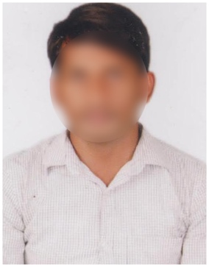
Email: sandeepdsxx@gmail.com
Mobile: 5542XXXX50
Address: H No. 12-214, Sector 4, Noida,
Uttar Pradesh 201301.

PROFESSIONAL SUMMARY

A sales Executive with 1+ years of experience who is ambitious and hard-working. Skilled in identifying and qualifying leads, on top of developing and closing deals. Seeking a challenging position in a fast-growing environment where I can use my skills and experience to make a valuable contribution.

WORK EXPERIENCE

Currently working as a Sales Executive at ABC Enterprises from 21 July 2022.

Major Responsibilities:
- Identify prospects and qualify leads.
- Regularly visiting and interacting with the customers to build rapport.
- Conduct vehicle demonstrations to explain the advantages of the products and answer customer questions.
- Understand the customer's needs, and budget and negotiate the price.
- Follow up with the customers and close the deals.
- Assist customers with the finance process and paperwork.
- Responds to customer complaints and ensure customer satisfaction.

EDUCATIONAL QUALIFICATION

- MBA Marketing from Brindavan Group of Institutions in 2022 with CGPA 8.1
- Intermediate (MPC) from BBMP Junior College in 2020 with CGPA 8.5
- 10th Class from Presidency School in 2018 with CGPA 8.2

PERSONAL DETAILS

Date of Birth : 25 July 2002
Gender : Male
Marital Status : Unmarried
Father’s Name : Vinay Kumar
Languages Known : English & Hindi
Hobbies : Reading books
Religion : Hindu
DECLARATION

I solemnly declare that all the above furnished information is true to the best of my knowledge and belief.

Place:
Date: Signature.

