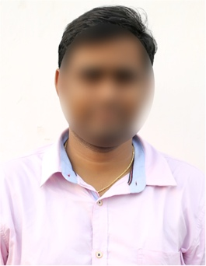
AVINASH PADALA

Mobile: 94123XXX75.
Email ID: avinashpdl@gmail.com
Address: 2-165, Madhurawada,
Visakhapatnam, Andhra Pradesh 530045.

PROFILE SUMMARY
An ambitious IT professional with 1 year of experience, with strong software engineering knowledge and skills, who can solve complex problems. I am self-motivated, productive, and capable of working under pressure.
I have proven track record of meeting deadlines and delivering high quality work. I am also a good team player who is able to work effectively with others to achieve common goals.
My strong interpersonal skills and accountability to assigned tasks make me a strong candidate for this job.
My goal is to use my coding skills to create software that enhances the organization's efficiency and effectiveness.

EMPLOYMENT DETAILS
Working as a software engineer at ABC Technologies, Hyderabad, since 1 July 2022 until now.

Key Responsibilities
- Write and debug the code both new and existing.
- Participate in code reviews to ensure the quality of the code.
- Test the software to ensure that is working perfectly, including unit testing, integration testing and system testing.
- Work with other developers as a team to collaborate on projects.
- Learn new technologies and keep up with the trends.
- Write reports about the progress of software projects.
- Provide support to the software users.

SKILLS
- Programming languages: Java, C++, JavaScript, SQL, CSS, HTML
- Operating systems: Windows, Linux
- Technical writing
- Data analysis
- Cloud computing using Amazon web services, Microsoft Azure

EDUCATION
- B. Tech Computer Science from Andhra University in 2022 with 8 GPA.
- Intermediate from Sri Chaitanya Junior College in 2018 with 82%.
- SSC from Srividya Niketan in 2016 with 85%.

PERSONAL DETAILS

Gender : Male
Date of birth : 05/07/2000
Nationality : Indian
Marital Status : Unmarried
Hobbies : Reading books & Playing Cri
Languages known : English, Hindi & Telugu

Declaration: I here by certify that all the above information is true to the best of my knowledge.

Place:
Date: Signature.

