SANDEEP YADAV
✆ Mobile: 9542XXXX250
Email Id: Sandeepydvxx@gmail.com

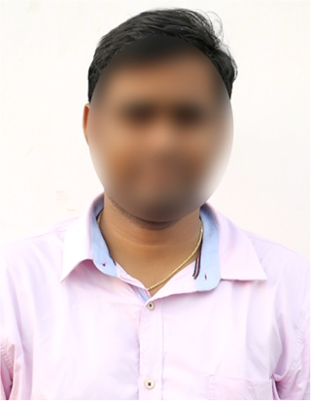
Date of Birth : 05 July 2003
Gender : Male
Father’s Name : Aravind Kumar
Religion : Hindu
Nationality : Indian
Marital Status : Unmarried
Educational Details :
Education | University/College | Year of Pass | Marks (GPA)
B.Sc. Computer Science | Vivekananda Degree College | 2023 | 8.2
Intermediate MPC | Narayana Jr College | 2020 | 8.7
10th Class | Brilliant Grammar High School | 2018 | 8.4

Work Experience : Fresher
Computer Skills : Ms Office (Word, Excel & PowerPoint)
Languages Known : English, Hindi & Telugu
Hobbies : Reading books, Playing Cricket
Address : 2-124, Narayanguda, Hyderabad,
Telangana 500027.

Declaration: I hereby declare that the information provided above is true to the best of my knowledge and belief.

Place: Hyderabad
Date: 08 Oct 2023 Signature

Template by : HRCabin.com

