GIRISH NAYYAR
Email: avinashjnxx@gmail.com
✆ Mobile no: 8451XXXX20

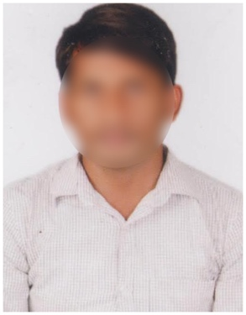
Position Applied : Electrician
Date of Birth : 07 Mar 2004
Work Experience : Fresher
Education : ITI Electrician

Qualification | Institution | Year | Marks
ITI Electrician | XXXX ITI College | 2023 | 8.1 GPA
10th Class | Vidyamandir Sr Secondary School | 2021 | 8 GPA

Father’s Name : Sravan Kumar
Gender : Male
Marital Status : Unmarried
Religion : Hindu
Computer Skills : MS Office
Hobbies : Playing Cricket
Languages Known : Tamil
Address : 2-125, XXXX Apartments,
Nungambakkam, Chennai,
Tamil Nadu 600034.
Place : Chennai
Date : 10/10/2023 Signature

