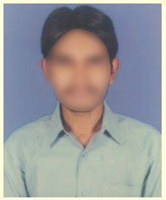
SUNIL JAIN

Mobile No : 8452XXXX25
Email ID : gayatrijnxx@gmail.com
Date of Birth : 07 Mar 2004
Work Experience : Fresher
EDUCATION

2020- 23 B.Com Computer Aditya Degree College 8 GPA
2018 – 20 Intermediate MPC AVN Jr College 8.1 GPA
2018 10th Class Srividya Niketan 8.2 GPA
PERSONAL INFORMATION

Gender : Male
Marital Status : Unmarried
Religion : Hindu
Father’s Name : Sravan Kumar
Computer Skills : MS Office (Word, Excel & PowerPoint)
Hobbies : Playing Cricket
Languages Known : English, Hindi & Tamil
Address : 4-124, XXXX Apartments,
Madhurawada,
Visakhapatnam,
Andhra Pradesh 530048.

Declaration: I hereby declare that all the information provided above is true to the best of my knowledge and belief.
Place : Chennai
Date : 10/10/2023 Signature

