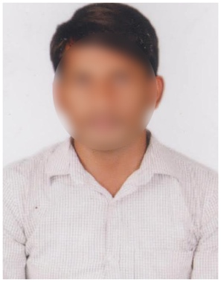
SANDEEP KOMMU
Email id: avinashkmrxx@gmail.com
Mobile No: 7540XXXX77.
LinkedIn:linkedin.com/in/sandeepknxx
Address: 15-1, Patan Cheru, Hyderabad,
Telangana 502319.

CAREER OBJECTIVE
Results-oriented individual with proficiency in Google Analytics and SEO fundamentals, seeking an entry-level digital marketing role to implement data-driven strategies and enhance online visibility.

ACADEMIC QUALIFICATION
- Bachelor of Commerce (B.Com) in Computers
XYZ University, Hyderabad, April 2023
- Intermediate (C.E.C)
ABC Junior College, Hyderabad, 2020 | 84%
- Secondary School (Class 10)
LMN High School, Hyderabad,2018 | GPA: 9.0/10

PROFESSIONAL SKILLS
- Digital Campaign Strategy
- Community Engagement & Growth
- Consumer Behaviour Data Analysis
- Email Marketing & List Management
- Product Promotion Campaigns
- Content Creation & Blogging
- SEO & Keyword Research

INTERSHIP EXPERIENCE
Marketing Intern
GHI Marketing Solutions, Hyderabad
July 2022 - September 2022
- Contributed to the formulation and implementation of digital marketing strategies.
- Managed social media communities, fostering growth and engagement.
- Analysed consumer data to guide targeted marketing strategies.
- Developed segmented email lists for effective campaign outreach.
- Supported promotional campaigns for new product introductions.
- Regularly contributed to the company’s blog, enhancing content outreach.
- Performed SEO keyword research, assisting in content optimization.

CERTIFICATIONS
- Digital Marketing Strategy Certification
- Data Analysis for Marketing Certification

PERSONAL INTERESTS
- Staying updated with the latest digital marketing trends
- Blogging about technology and marketing
- Photography and graphic design

PERSONAL DETAILS
Father’s Name : Krishna Kommu
Date of Birth : March 5, 2001
Gender : Male
Nationality : Indian
Marital Status : Unmarried
Languages Known : English, Telugu

DECLARATION

I hereby declare that the information provided in this resume is true to the best of my knowledge.

Place:
Date: Signature

