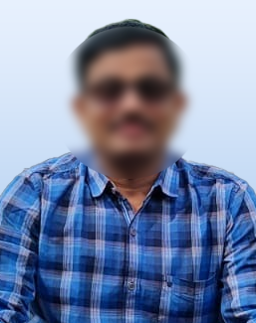
ARJUN CHANDRA
Mobile : 8252XXXX15
Email Id : arjunchaxxx@gmail.com

CAREER OBJECTIVE
To work as a primary school teacher at a prominent educational institution with a focus on English or Science subjects. Possess the ability to conduct tests, evaluate students, and enhance their skills.
Name of Exam | Year of Passing | College/University | Percentage/GPA
10th Class | 2019 | Govt School | 7.8 GPA
Intermediate C.E.C | 2021 | Govt Jr College | 8.2 GPA
B.Com | 2024 | Guru Nanak College | 7.9 GPA
EDUCATION

WORK EXPERIENCE
Working Experience : Primary School Teacher at XYZ School
(01 January 2023 to Present)
PERSONAL DETAILS
Father’s Name : Subhash Chandra
Date of Birth : 17 Feb 2001
Computer Skills : MS Word, Excel, & PowerPoint
Photo Shop CC 2023.
Gender : Male
Marital Status : Unmarried
Religion : Hindu
Nationality : Indian
Languages Know : English & Tamil
Hobbies : Reading books & listening to music.
Address : 12-1, Vasanth Apartments, Nungambakkam, Chennai, Tamil Nadu 600034.

Date: (Arjun Chandra)

